Practical - 1

Aim: To Implementation and Time analysis of sorting algorithms. Bubble sort, Selection sort, Insertion sort, Merge sort and Quicksort.
1)Bubble Sort Algorithm:
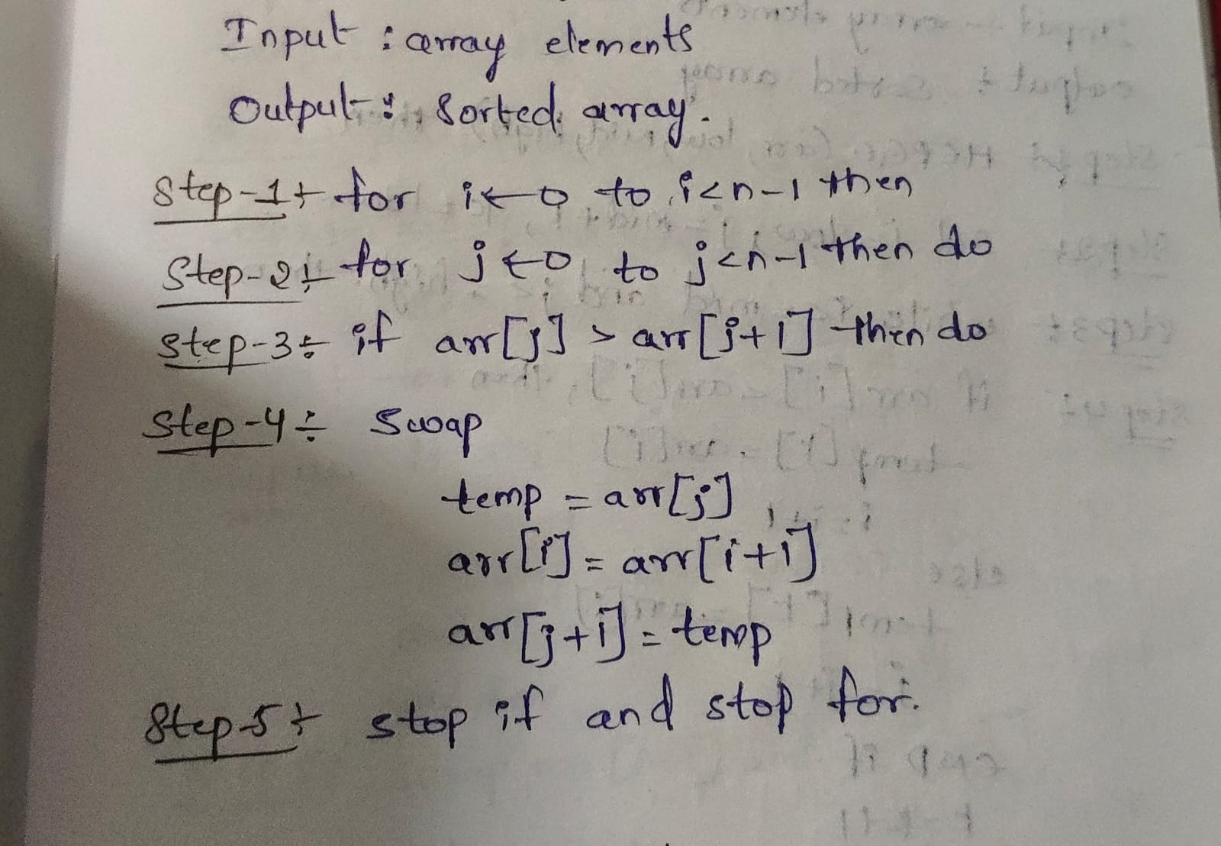

Program:
#include <iostream>
Using namespace std;
Class BubbleSort
{ public:
int arr[100], n;
void arrayInput()
{
Cout << ”Enter number of elements:”;
Cin>>n;

Cout << “Enter the elements:”;
For(int i = 0;i<n;i++)
{
Cin>>arr[i];
}
}
Void printArray(){
For (int i = 0; i<n;i++){
Cout << arr[i] << “ “;
}

Output:

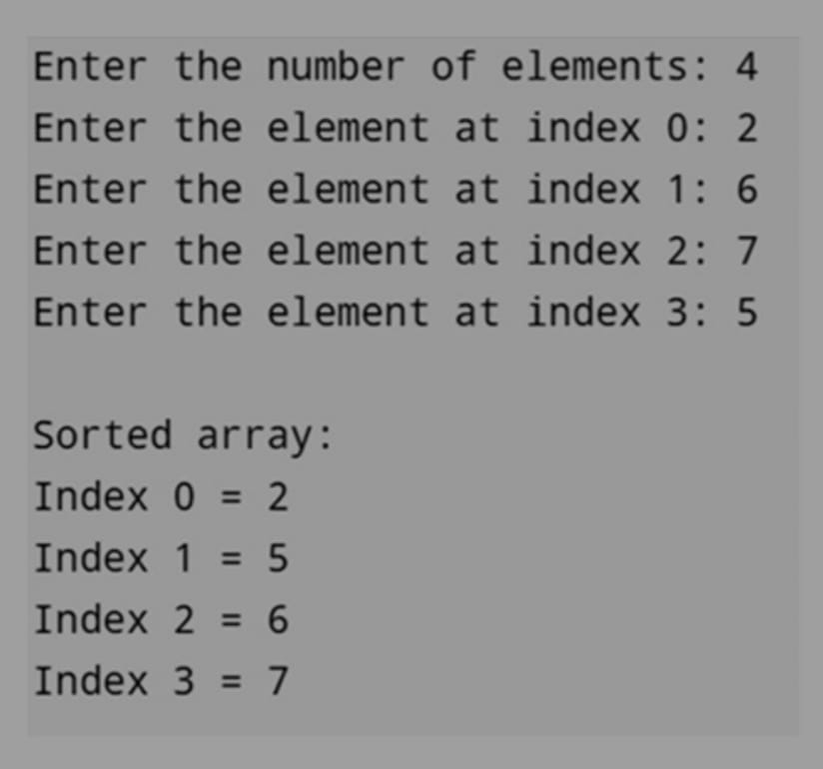

Time Complexity:

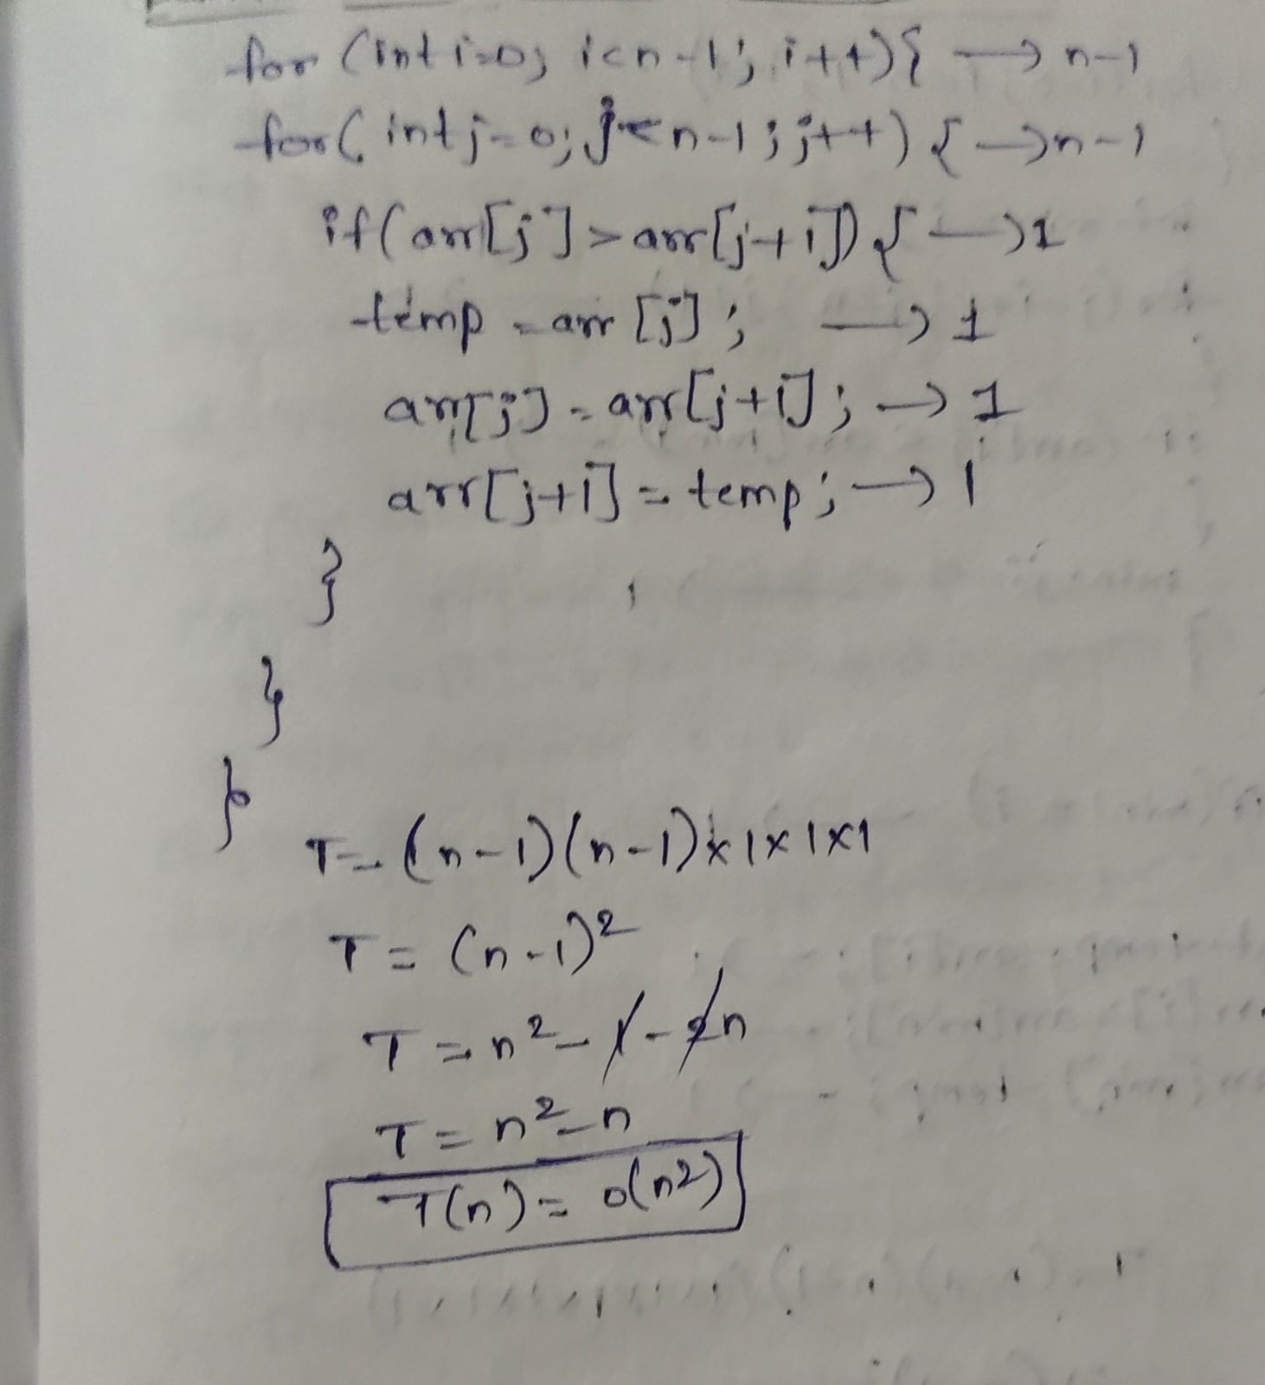

2) Selection sort:
Algorithm:
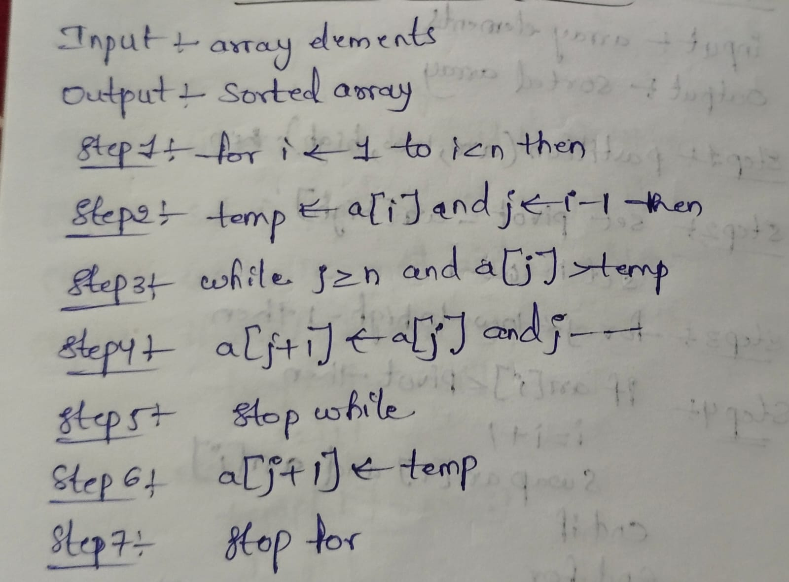

Program:
#include <iostream>
using namespace std;
class SelectionSort{
public:
int arr[100], n; void arrayInput(){
cout << "Enter number of elements: ";
cin >> n; cout << "Enter the
elements: "; for (int i = 0; i < n; i++){
cin >> arr[i];
}
} void logic(){ int i, j,
min, temp; for (i = 0; i < n
- 1; i++){ min = i;
for (j = i + 1; j < n; j++){
if (arr[j] < arr[min]){
min = j;
}; int
main()
{
SelectionSort ss;
ss.arrayInput(); cout <<
"Before Sorting: ";
ss.printArray(); ss.logic();
cout << "After Sorting: ";
ss.printArray(); return 0;
}
Output:
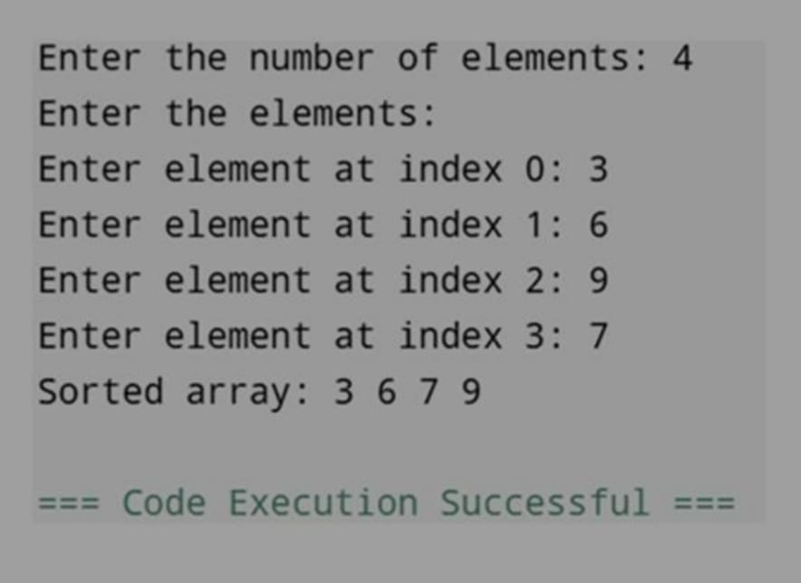

Time complexity:
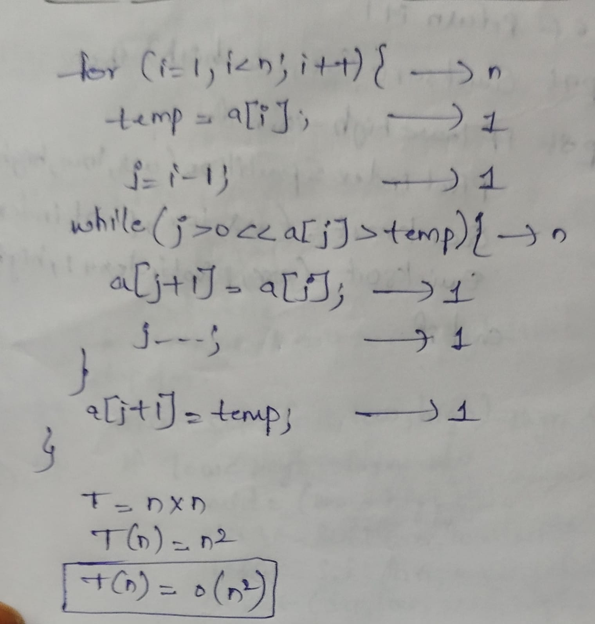

3) Insertion sort:

Algorithm:

Program:
#include <iostream> using namespace std; class InsertionSort
{ public:
int arr[100], n; void arrayInput()
{
cout << "Enter number of elements: ";
cin >> n;

cout << "Enter the elements: "; for (int i = 0; i < n; i++)
{ cin >> arr[i];
} }
void logic()
{
int i, j, key;

for (i = 1; i < n; i++)
{
key = arr[i]; j = i - 1;

while (j >= 0 && arr[j] > key)
{
arr[j + 1] = arr[j];
j--;
}

arr[j + 1] = key;
}
}
void printArray()
{
for (int i = 0; i < n; i++)
{
cout << arr[i] << " ";
}
cout << endl;
}
};

int main()
{
InsertionSort is;

is.arrayInput();

cout << "Before Sorting: ";
is.printArray();

is.logic();

cout << "After Sorting: ";
is.printArray();

return 0;
}

Output:

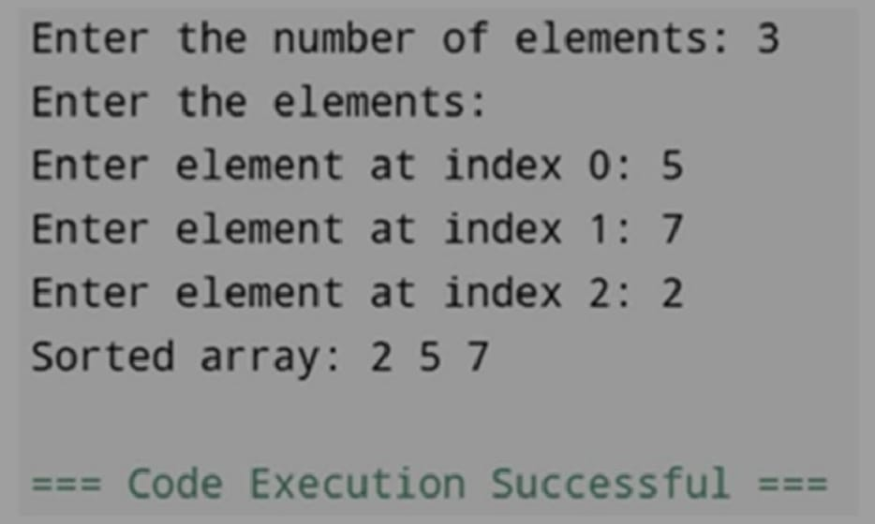

Time Complexity:
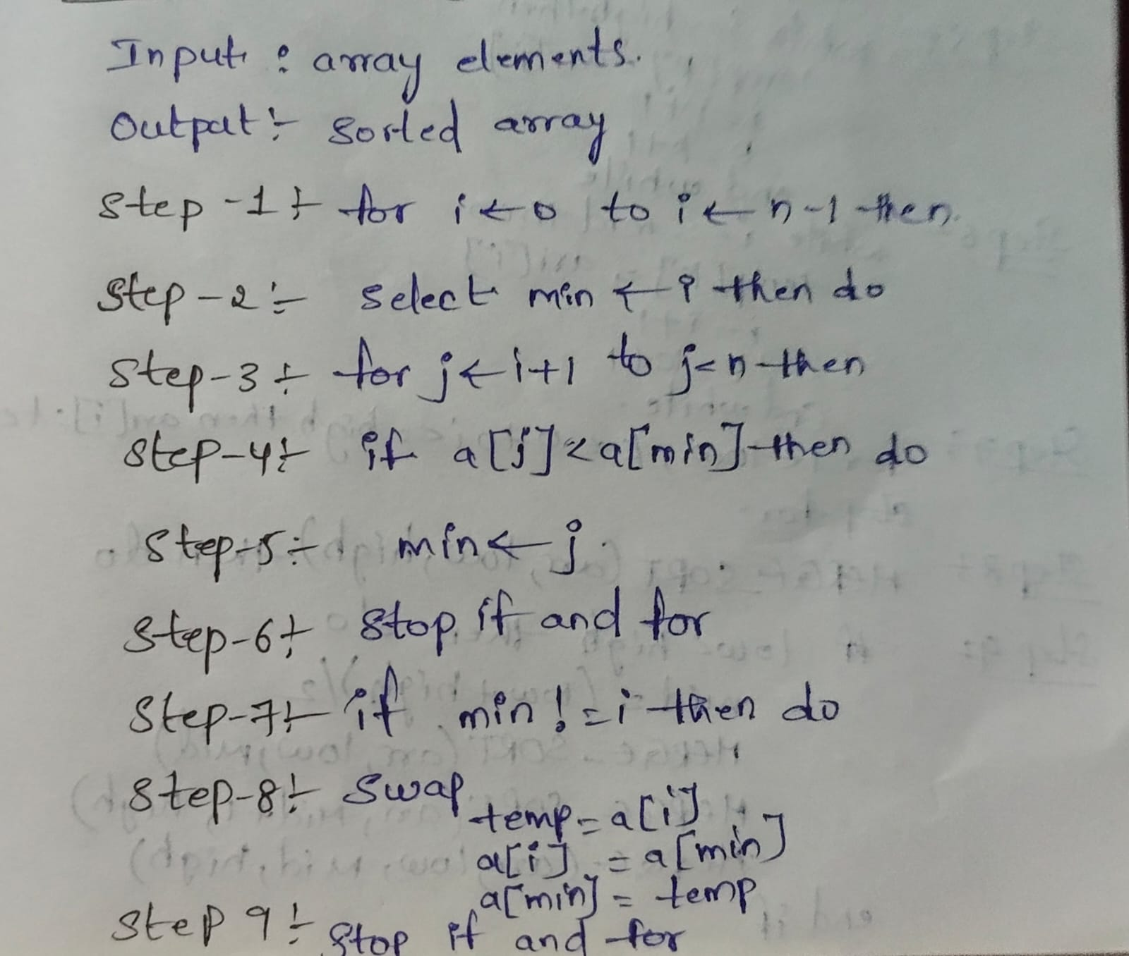

4)Merge Sort: Algorithm:
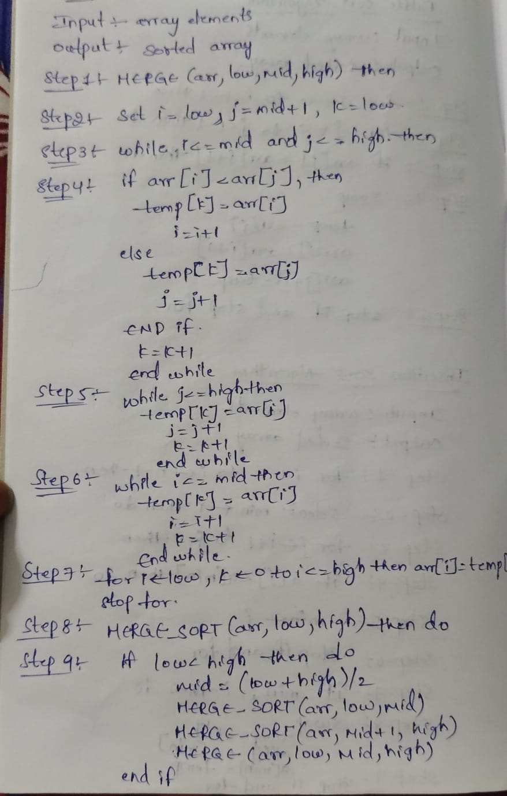
  Program:  #include <iostream> using namespace std; class MergeSort{ public:  int arr[100],n; void arrayInput(){  cout << "Enter number of elements: "; cin >> n;  cout << "Enter the elements: "; for (int i = 0; i < n; i++){ cin >> arr[i];  }  }  void merge(int low, int mid, int high){ int temp[100]; int i = low; int j = mid + 1;  int k = low;  while (i <= mid && j <= high){ if (arr[i] < arr[j]){ temp[k] = arr[i];  i++;  } else{  temp[k] = arr[j];  j++;  } k++;  }  while (i <= mid)  {  temp[k] = arr[i];  i++; k++;  }  while (j <= high)  {  temp[k] = arr[j];  j++; k++;  }  for (i = low; i <= high; i++)  {  arr[i] = temp[i];  }  } | Faculty of Engineering & Technology  Department of CSE-AI&ML  Design and analysis of algorithm – 01AI0506
void logic(int low, int high)
{
if (low < high)
{
int mid = (low + high) / 2; logic(low, mid); logic(mid + 1, high); merge(low, mid, high);
}
}
void printArray()
{
for (int i = 0; i < n; i++)
{
cout << arr[i] << " ";
}
cout << endl;
}
};

int main()
{
MergeSort ms;

ms.arrayInput();

cout << "Before Sorting: "; ms.printArray();

ms.logic(0, ms.n - 1);

cout << "After Sorting: ";
ms.printArray();

return 0;
}

Output:

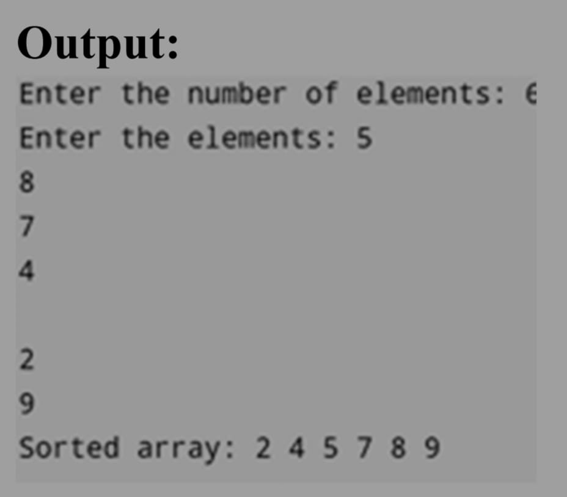

Time Complexity: 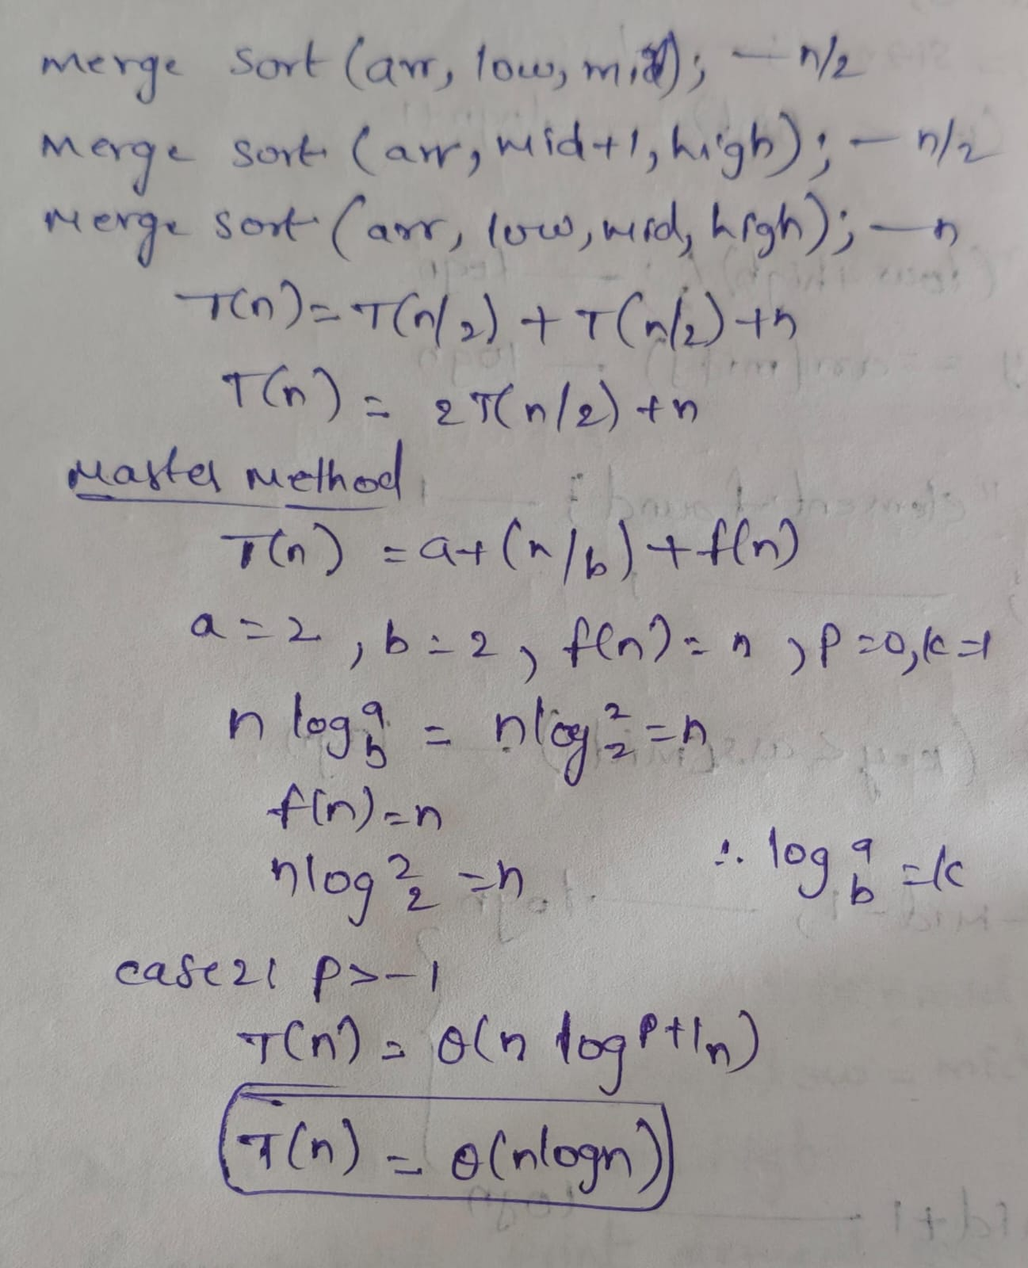

5)Quick Sort:

Algorithm: 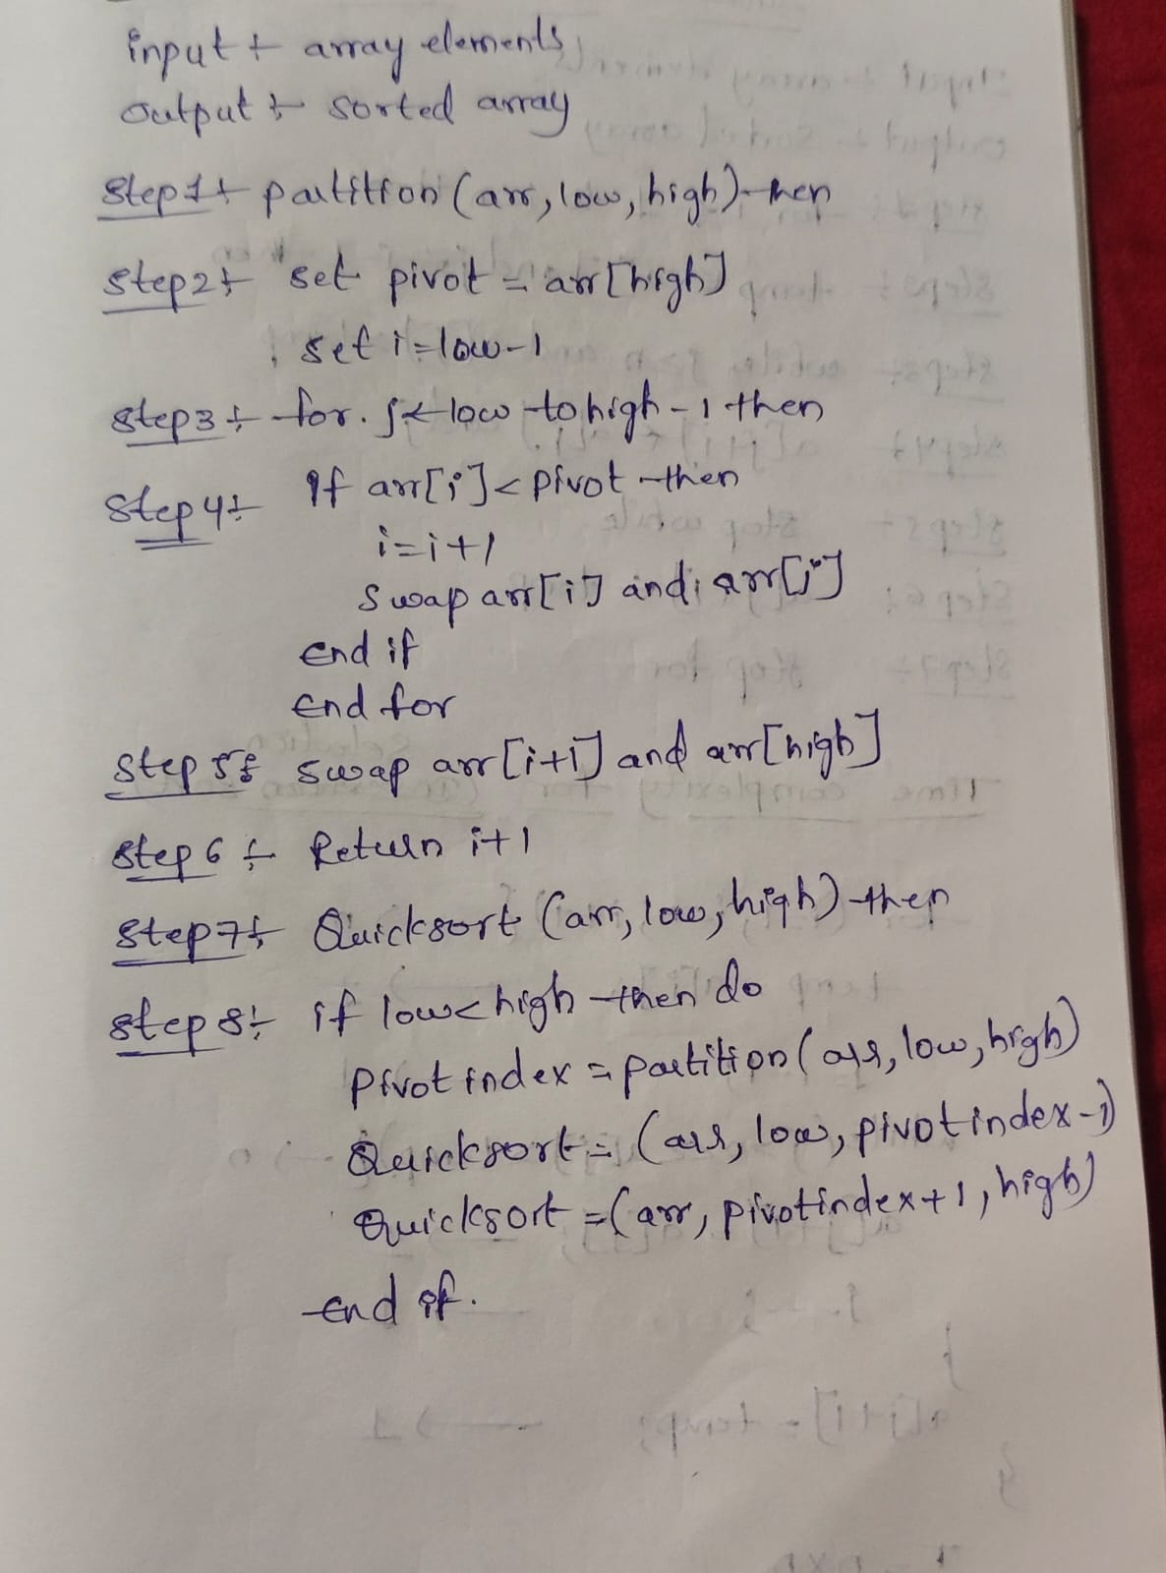

Program:

#include <iostream> using namespace std; class QuickSort
{ public:
int arr[100], n; void arrayInput()
{
cout << "Enter number of elements: ";
cin >> n;

cout << "Enter the elements: "; for (int i = 0; i < n; i++)
{
cin >> arr[i];
}
}
void printArray()
{
for (int i = 0; i < n; i++)
{
cout << arr[i] << " ";
}
  cout << endl;  }  int partition(int arr[], int lb, int ub)  {  int pivot = arr[lb]; int start = lb; int end = ub;  while (start < end)  {  while (arr[start] <= pivot && start < ub)  {  start++;  }  while (arr[end] > pivot)  {  end--;  }  if (start < end)  {  swap(arr[start], arr[end]);  }  }  swap(arr[lb], arr[end]);  return end;  }  void quicksort(int arr[], int lb, int ub)  {  if (lb < ub)  {  int location = partition(arr, lb, ub);  quicksort(arr, lb, location - 1); quicksort(arr, location + 1, ub);  }  } | Faculty of Engineering & Technology  Department of CSE-AI&ML  Design and analysis of algorithm – 01AI0506
void sort()
{
quicksort(arr, 0, n - 1);
}
};

int main()
{
QuickSort qs;

qs.arrayInput();

cout << "\nBefore Sorting: "; qs.printArray();

qs.sort();

cout << "After Sorting: "; qs.printArray();

return 0;
}

Output: 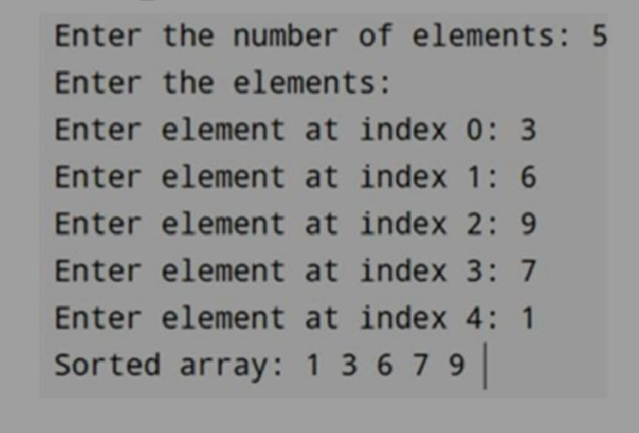

Time Complexity:

